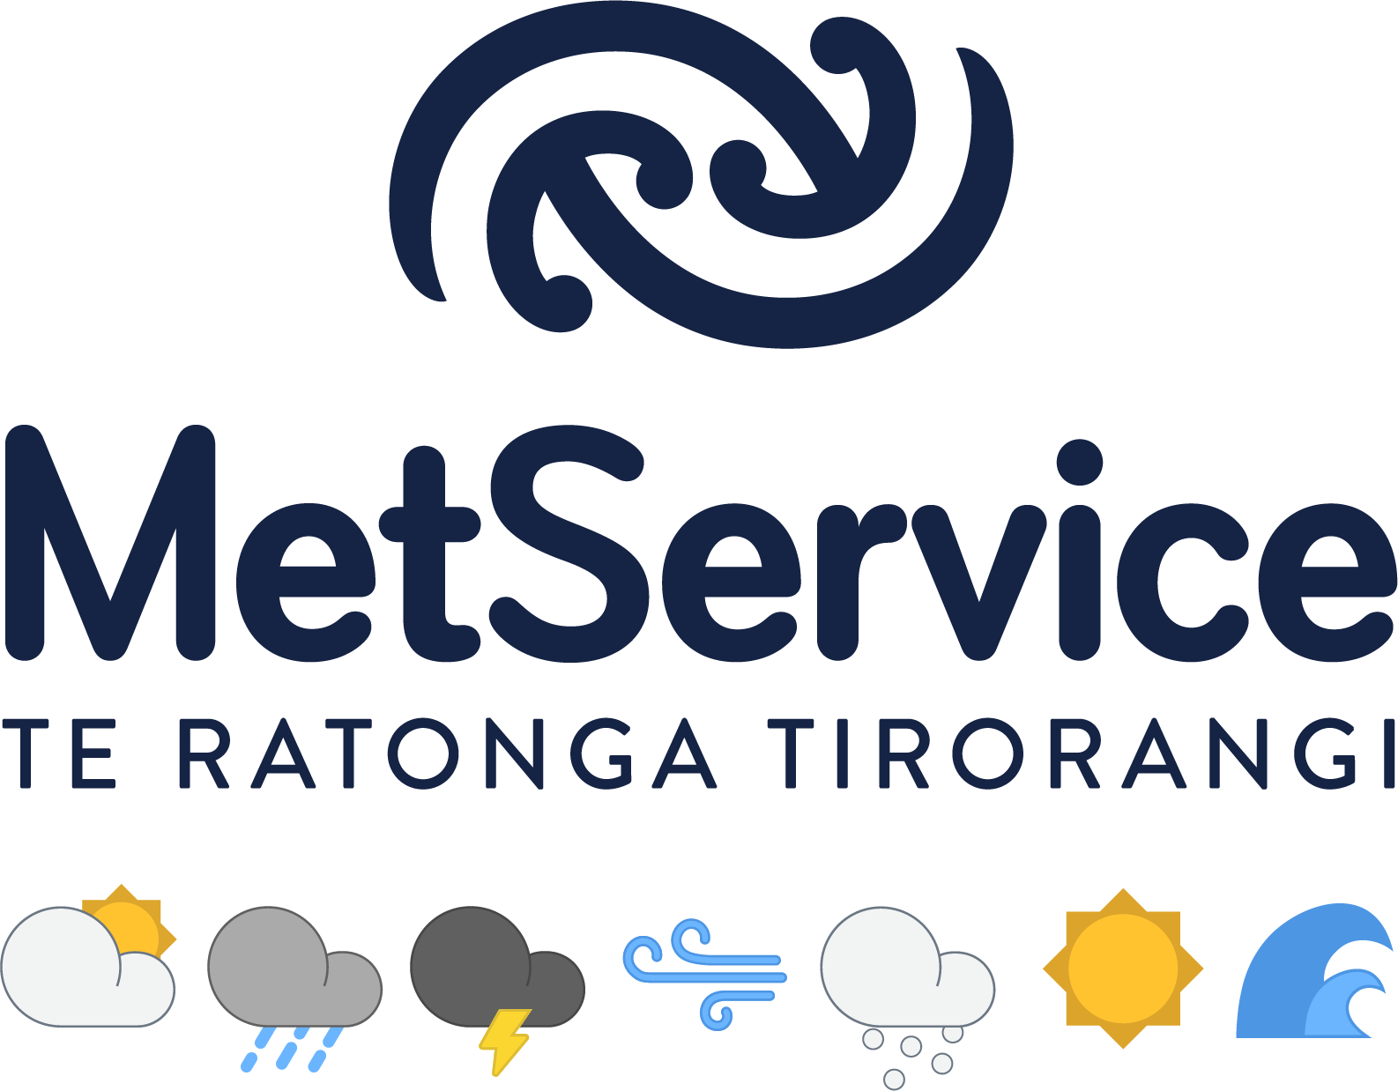
Media release

For immediate release
1 August 2019
$11.5 million project to revolutionise ocean forecasting launches
A bold new project that will revolutionise New Zealand’s ability to comprehensively measure, monitor and predict the state of our oceans, was launched on Tuesday [30 July].
New Zealand’s leading experts in oceanography joined MetService and eastern Bay of Plenty iwi Whakatōhea for the launch of the Moana Project at Omarumutu Marae in Ōpōitki.
MetService’s Chief Executive Peter Lennox says the launch marks the initiation of the $11.5 million, five-year research project, which is funded through the Ministry of Business, Innovation and Employment’s Endeavour Fund.
The project, which was spearhead by MetService’s oceanography division MetOcean Solutions, will greatly enhance New Zealand’s understanding of our changing oceans.
“We’ll be creating a number of tools that will make New Zealand a world leader in ocean forecasting. To make this happen, we’ve brought together all of New Zealand’s oceanographic research institutions and will be combining their expertise and research with indigenous knowledge.”
General Manager MetOcean Solutions Dr Brett Beamsley says, New Zealand’s oceans are very poorly understood, and with rising ocean temperatures this is compounded.
“As an island nation New Zealander’s derive wellbeing and wealth from the oceans that surround us. To protect these benefits for future generations, we need to better understand our marine environment.”
“The Moana Project will greatly advance understanding of marine heatwaves, ocean circulation, and connectivity, enabling us to better protect and manage the marine environment and its resource,” says Dr Beamsley.
The Moana Project’s programme director and MetService’s Head of Research Partnerships Professor Moninya Roughan says New Zealand sits in a hotspot of ocean warming.
“The Tasman Sea is warming at one of the fastest rates on Earth, up to three times the global average. The research from the Moana Project will help understand the impact this has on our kaimoana (seafood) and in terms of species movement and abundance.“
This project combines mātauranga Māori with science. Iwi partners Whakatōhea will bring their traditional and contemporary oceanographic knowledge and aquaculture experience to the project.
Whakatōhea Māori Trust Board, Chair Robert Edwards says the Whakatōhea iwi has been living in the Ōpotiki area for approximately 900 years and has built its indigenous knowledge systems around the land and sea over generations.
“With the development of our off-shore mussel farm in Whakatōhea rohe moana, we take responsibility for ensuring we know as much as we can regarding future issues that could impact the water space and to enable our role as kaitiaki.
“The sea temperatures are rising, and this project will help all, Māori and non-Māori, understand the impact it will have on our kaimoana now and into the future,” says Robert Edwards.
MBIE Manager Contestable Investments, Dr Max Kennedy says this impressive project combines cutting-edge science and innovation, with Mātauranga Māori that will be applied to provide tools that protect the wellbeing of New Zealanders.
“Our seafood sector alone is worth more than $4 billion annually to New Zealand’s economy and its resources are directly threatened by rising ocean temperatures and marine heatwaves.
“The project will shed new light on how to safeguard the sustainability of our blue economy. In doing so it will allow for informed evidence-based decision making to be made across a whole range of economic, environmental and social applications,” says Dr Kennedy.
The project will partner with the seafood sector to develop low-cost ocean sensors that will revolutionise ocean data collection.
The sensors created by Nelson company Zebra-Tech will be deployed throughout New Zealand’s exclusive economic zone with support from the commercial fishing sector’s fleet.
“This has never been done before. It’s like crowdsourcing but to get a huge amount of ocean temperature data,” says Professor Roughan.
The ocean forecasting model developed through the Moana Project will bring in historical and new data focused on New Zealand waters.
“To date ocean forecasters and industries have had to rely on models and satellites operated by other countries. We’ve been missing fine-scale resolution, and these models haven’t been attuned to New Zealand coastal ocean characteristics,” says Professor Roughan.
“Through the Moana Project we will fill that huge gap and make the results accessible to everyone – through an open access tool.”
ENDS
For more information or to request an interview please contact:
Andrea Tandy, Senior Communications Advisor, MetService. Mobile 0275 700 721 or email andrea.tandy@metservice.com

NOTES TO EDITORS
The Moana Project was spearheaded by MetService’s oceanographic division MetOcean Solutions and involves all New Zealand’s oceanography research institutes, including the Cawthron Institute, NIWA, Victoria University of Wellington, and Auckland, Waikato, and Otago Universities.
A partnership with Whakatōhea Māori Trust Board will bring indigenous ocean knowledge to the project. Technology partner Zebra-Tech are creating ocean sensors.

This stellar New Zealand team is collaborating with international experts from Rutgers, the State University of New Jersey, and the University of Hawaii, US; the Australian Bureau of Meteorology and the University of New South Wales, Australia.

The project also has support from a wide range of ocean-information end-users, including the New Zealand Defence Technology Agency, the seafood sector including Seafood NZ, Paua Industry Council, Rocklobster Industry Council, Deepwater Group, the Ministry for Primary Industries and district and regional councils.

Images and captions
Please use the following dropbox link for images from the Moana launch in Ōpōtiki
Dropbox Link: https://www.dropbox.com/sh/5rjdil6qagskl07/AACGY8a_LdR9cahXozKDYQyea?dl=0

About MetService
MetService is New Zealand’s National Meteorological Service and the only authorised provider of Severe Weather Watches and Warnings. MetOcean Solutions was fully acquired MetService in September 2017. Met Ocean Solutions is the oceanography division of MetService providing operational oceanographic expertise. As a State-Owned Enterprise MetService’s core purpose is to protect the safety of life and property in New Zealand while operating as a commercial business.

